[GITHUB REPOSITORY](https://github.com/OmarAttia95/FHIR_ETL_Project/blob/main/airflow_dag_workflow.py)

|  |
| --- |
| 01000741752 |
| Smart Phone |
| Omar123915@hotmail.com |
| Envelope |
| Omar Hossam Attia |
| User |

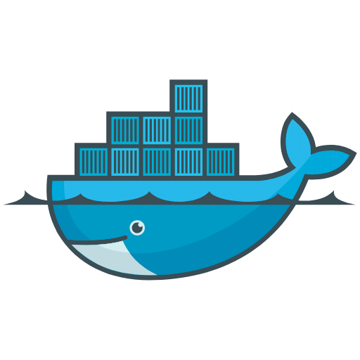

Dockerfile Instructions & Documentation

Dear,

This Dockerfile is designed to set up an **Apache Airflow** environment with Python 3.8 using the **Apache Airflow 2.5.0 Docker image**. It installs necessary Python packages and prepares the environment for running Airflow DAGs. Follow the steps below to build and run the Docker image:

**Step 1: Create the Dockerfile**

Save the provided Dockerfile contents into a file named Dockerfile.

Ensure the file is in the directory where you will build the Docker image.

**Step 2: Add the Required Files**

Place the airflow_dag_workflow.py file in the same directory as the Dockerfile.

If the DAG file is not available locally, download it from the following GitHub repository:

Airflow DAG [GitHub](https://github.com/OmarAttia95/FHIR_ETL_Project/blob/main/airflow_dag_workflow.py) Repository.

**Step 3: Build the Docker Image**

Navigate to the directory containing the Dockerfile in the terminal.

#bash docker build -t airflow_custom:latest .

Replace airflow_custom with a name of your choice for the Docker image.

**Step 4: Run the Docker Container**

#bash docker run -p 8080:8080 airflow_custom:latest

This maps the Airflow web server to port 8080 on your local machine.

You can access the Airflow UI at: <http://localhost:8080>.

**Known Issue**

During testing, the container build failed due to file permissions issues with the airflow_dag_workflow.py file being copied into the Docker container. Attempts to resolve these permissions issues in the current setup were unsuccessful. We will meet to discuss the workarounds.

Omar Hossam Attia

Analytics engineer